1. Project Idea in Detail:

The core idea of this project is to develop a system that can automatically generate and optimize university course timetables. University timetabling is a well-known constraint satisfaction and optimization problem involving assigning courses, lecturers, students, rooms, and time slots while adhering to various constraints (e.g., no conflicts, sufficient capacity, required equipment, lecturer availability).The project aims to find a timetable solution that maximizes a calculated 'fitness' score, which is determined by minimizing the violation of defined constraints. The system provides a graphical user interface (GUI) to configure problem parameters, run different optimization algorithms, and visualize the generated timetables and algorithm progress.

The project aims to solve the university timetable problem, which involves scheduling courses for students, lecturers, and rooms across multiple days and hours while adhering to constraints such as:
- No overlapping schedules for lecturers or students.
- Room capacity and equipment compatibility (e.g., projectors, computers).
- Lecturer availability and course-specific requirements (e.g., lab sessions).
- Minimizing conflicts and optimizing resource utilization.

The system is designed to be flexible, allowing users to input parameters like the number of courses, lecturers, students, and population size for optimization. It visualizes the resulting timetable, tracks algorithm performance, and provides detailed conflict analysis, making it a valuable tool for academic institutions.

2. Main Functionalities

The application provides several key functionalities:

- Problem Generation: It can generate a university timetable problem instance with a specified number of courses, lecturers, students, rooms (lecture halls and labs), days, and hours per day. Rooms have properties like capacity, type (lecture/lab), projector, and computer availability. Lecturers have names, IDs, and availability schedules. Courses have names, assigned lecturers, enrolled students, duration, required equipment, lab components, and multiple sections. Students have names and enrollments in multiple courses.

- Constraint Evaluation: The system includes a detailed mechanism to evaluate a given timetable solution. It identifies and counts various types of violations, such as room conflicts, lecturer conflicts, student conflicts, room capacity issues, equipment mismatches, lecturer unavailability, room type mismatches (lecture in lab or vice-versa), and missing lecture or lab sessions Each violation type has a defined penalty value and the total fitness of a timetable is calculated by subtracting the sum of penalties from a base value.

- Algorithm Implementation: It implements three metaheuristic optimization algorithms to search for optimal timetables:

Particle Swarm Optimization (PSO)

Genetic Algorithm (GA)

Hybrid Algorithm (combining aspects of PSO and GA)

- Timetable Generation: It can generate random initial timetables and apply algorithm-specific updates (velocity application in PSO, crossover and mutation in GA).

- Algorithm Comparison: The application can run the three implemented algorithms sequentially and display a summary of their performance, including final fitness, execution time, and detailed violation counts.

- Visualization and Display: The GUI allows users to:

- View lists of generated rooms, courses, and students.

- View details for a specific lecturer, including their courses and availability.

- Display the details of the current best timetable solution.

- Show a summary of the solution's fitness and violation counts.

- Plot the progress of average and best fitness values over iterations/generations.

- Plot the progress of average constraint violations over iterations/generations.

- Display a list of specific conflicts found in the best timetable solution.

- Generate and display individual timetables for students65....

- Loading Screen: Includes a video loading screen with optional audio playback using pygame and OpenCV

3. Similar Applications in the Market
Several commercial and open-source applications address university timetables, each with distinct features:
- Unischeduler:
  - A web-based timetable solution for universities, focusing on automated scheduling with customizable constraints.
  - Features include cloud-based access, integration with student information systems, and conflict resolution.
  - Unlike our system, it lacks advanced optimization algorithms like PSO or GA and does not emphasize algorithm comparison.
- MIMOSA Scheduling Software:
  - A commercial tool for educational institutions, supporting course and exam scheduling.
  - Offers robust constraint management but is proprietary and expensive, limiting accessibility for smaller institutions.
  - Our system is open-source and includes a multimedia loading screen, which MIMOSA lacks.
- FET (Free Timetabling Software):
  - An open-source desktop application using heuristic algorithms for timetabling.
  - Supports complex constraints and is widely used in schools and universities.
  - Compared to our system, FET does not provide algorithm comparison or a dynamic GUI with multimedia features.
- OptaPlanner:
  - An open-source constraint solver used for timetabling and other optimization problems.
  - Integrates with Java-based systems and supports custom algorithms but requires significant configuration.
  - Our system is Python-based, more accessible for academic use, and includes a user-friendly Tkinter interface.
Our system stands out for its focus on comparing PSO, GA, and Hybrid algorithms, its multimedia-enhanced GUI, and its emphasis on visualizing optimization progress and conflicts, which are not commonly found in existing solutions.

4. Literature Review of Academic Publications
The following academic papers are relevant to the university timetabling problem and the optimization algorithms used in our project. These papers were selected to align with the project’s focus on metaheuristic algorithms and timetabling, considering the team of five members.
- Burke, E. K., McCollum, B., Meisels, A., Petrovic, S., & Qu, R. (2007). "A graph-based hyper-heuristic for educational timetabling problems." European Journal of Operational Research, 176(1), 177-192.
  - Summary: This paper introduces a graph-based hyper-heuristic approach for university course timetabling, focusing on handling complex constraints like room allocation and lecturer availability. It proposes a flexible framework that combines multiple low-level heuristics to generate feasible timetables.
  - Relevance: The paper’s emphasis on constraint satisfaction and heuristic optimization aligns with our system’s constraint management and use of metaheuristic algorithms (PSO, GA, Hybrid). It provides insights into handling hard and soft constraints, which informed our penalty-based fitness function.
  - Key Insight: The use of hyper-heuristics inspired our exploration of combining PSO and GA in the Hybrid algorithm to balance exploration and exploitation.
Link: https://www.sciencedirect.com/science/article/abs/pii/S0377221705010139
- Lü, Z., & Hao, J. K. (2010). "Adaptive Tabu Search for course timetabling." European Journal of Operational Research, 200(1), 235-244.
  - Summary: This paper presents an adaptive Tabu Search algorithm for university course timetabling, incorporating a memory mechanism to avoid redundant solutions. It demonstrates improved performance over traditional methods on benchmark datasets.
  - Relevance: While our system uses PSO and GA, the paper’s focus on adaptive optimization techniques influenced our Hybrid algorithm’s dynamic alternation between PSO and GA operations. The discussion on constraint violations guided our violation tracking mechanism.
  - Key Insight: The adaptive nature of the algorithm highlighted the importance of dynamically adjusting optimization strategies, which we incorporated into our Hybrid approach.
Link: https://www.sciencedirect.com/science/article/abs/pii/S0377221709000282
- Abdullah, S., Burke, E. K., & McCollum, B. (2007). "Using a randomised iterative improvement algorithm with composite neighbourhood structures for the university course timetabling problem." In Metaheuristics (pp. 153-169). Springer.
  - Summary: This paper explores a randomized iterative improvement algorithm with composite neighborhood structures for course timetabling. It tests the approach on real-world university datasets, achieving competitive results.
  - Relevance: The use of metaheuristic algorithms and neighborhood structures is closely related to our GA’s crossover and mutation operations. The paper’s evaluation methodology inspired our algorithm comparison framework.
  - Key Insight: The concept of composite neighborhood structures informed our mutation strategy in GA, where we randomly alter room assignments or time slots to explore the solution space.
Link: https://link.springer.com/chapter/10.1007/978-0-387-71921-4_6
- Soria-Alcaraz, J. A., Ochoa, G., Swan, J., Carpio, M., Puga, H., & Burke, E. K. (2014). "Effective learning hyper-heuristics for the course timetabling problem." European Journal of Operational Research, 238(1), 77-86.
  - Summary: This paper proposes a learning-based hyper-heuristic framework for course timetabling, using machine learning to select appropriate heuristics dynamically. It outperforms static heuristic methods on standard datasets.
  - Relevance: The learning aspect of the hyper-heuristic approach inspired our exploration of combining PSO’s global search with GA’s local refinement in the Hybrid algorithm. The paper’s focus on benchmark datasets highlighted the need for synthetic data flexibility in our system.
  - Key Insight: The dynamic selection of heuristics encouraged us to implement a probabilistic switch between PSO and GA in the Hybrid algorithm to adapt to the problem’s complexity.
Link: https://www.sciencedirect.com/science/article/abs/pii/S0377221714002331
- Al-Betar, M. A., Khader, A. T., & Zaman, M. (2012). "University course timetabling using a hybrid harmony search metaheuristic algorithm." IEEE Transactions on Systems, Man, and Cybernetics, Part C (Applications and Reviews), 42(6), 664-681.
  - Summary: This paper introduces a hybrid harmony search algorithm for university course timetabling, combining global and local search strategies. It demonstrates robust performance on ITC datasets, handling both hard and soft constraints effectively.
  - Relevance: The hybrid approach in this paper directly influenced our Hybrid PSO-GA algorithm, which combines PSO’s swarm-based exploration with GA’s evolutionary operations. The paper’s constraint handling techniques informed our penalty assignments.
  - Key Insight: The success of hybrid metaheuristics in timetabling reinforced our decision to develop a Hybrid algorithm to leverage the strengths of both PSO and GA.
Link: https://ieeexplore.ieee.org/document/6146399
These papers collectively highlight the effectiveness of metaheuristic and hybrid approaches in solving the university timetabling problem, providing a theoretical foundation for our system’s algorithm design and constraint management strategies.

5. The Dataset Employed
The application primarily uses synthetic data generated within the code itself rather than a publicly available dataset.
- Room data (ID, capacity, type, equipment) is generated randomly based on the specified NUM_LECTURE_HALLS and NUM_LAB_ROOMS.
- Lecturer data (ID, name, availability) is generated randomly. Names are chosen from an embedded list Doctors_dataset, and availability is randomly set to False for some slots.
- Course data (ID, name, lecturer, duration, requirements, sections, lab component) is generated randomly. Course names are selected from an embedded list courses_dataset. Students are initially assigned as an empty list.
- Student data (ID, name, courses) is generated randomly. Student IDs start from a base number (2022000). Names are chosen from an embedded list students_list, which is initially populated from a CSV file students.csv (path mentioned in the source). However, the actual student generation function generate_students does not use the CSV data—it creates sample students with generated IDs and names. Students are then randomly assigned to 3–6 courses each, and course enrollment lists are updated accordingly.
Therefore, the dataset used is internal and dynamically generated for each run, not loaded from any standard external or public source. The mention of students.csv and the embedded lists Doctors_dataset and courses_dataset are solely used for generating random attributes, while the core problem instance—including who teaches what, who takes what, and room capacities—is constructed programmatically during the UniversityTimetablingProblem initialization.

6. Details of the Algorithm(s)/Approach(es) Used and the Results of the Experiments
The application implements three metaheuristic algorithms: Particle Swarm Optimization (PSO), Genetic Algorithm (GA), and a Hybrid approach. All algorithms operate on the Timetable object, which represents a potential solution as a list of CourseAssignment objects.
- Representation:
A timetable is represented as a list of CourseAssignment objects. Each assignment specifies the course ID, section ID, room ID, time slot (day and hour), and whether it's a lab session.
- Fitness Function:
The quality of a timetable is measured by its fitness score, calculated via the evaluate_timetable method. It penalizes:
  - Hard constraints: room conflicts, lecturer conflicts, room type mismatches, missing sessions.
  - Soft constraints: student conflicts (penalized per overlapping student), room capacity issues (per over-capacity student), equipment mismatches, and lecturer unavailability.
The base fitness starts at 10,000, from which penalties are subtracted. A higher score means a better timetable.
HYPER PRAMETARS:
video_path1 = r"C:\Users\Adham\Downloads\tenor.gif"
music_path1 = r"D:\Unwind(MP3_160K).mp3"
NUM_DAYS = 5
NUM_HOURS = 10
MAX_SECTIONS_PER_COURSE = 3
W_MAX = 0.9
W_MIN = 0.4
C1 = 1.49
C2 = 1.49
CROSSOVER_RATE = 0.8
MUTATION_RATE = 0.2
TOURNAMENT_SIZE = 3

Let’s discuss constraints or violations in project
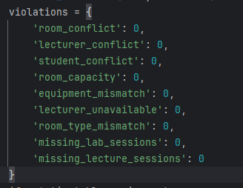
As it shown We have 9 constraints but 1.
room conflict
- Meaning: Two or more courses are scheduled in the same room at the same time.
lecturer conflict
- Meaning: A lecturer is scheduled to teach two different courses simultaneously.
student conflict
- Meaning: A student group is scheduled to attend two courses at the same time.
room capacity
- Meaning: A room is assigned to a course with more students than the room's capacity.
equipment mismatch
- Meaning: A course requires equipment (projector/computers) that the room doesn't have.
lecturer unavailable
- Meaning: A course is scheduled when the lecturer is marked as unavailable.
room type mismatch
- Meaning: A lab course is scheduled in a lecture hall or vice versa.
missing lab sessions
- Meaning: A course that requires lab sessions has none scheduled.
missing lecture sessions
- Meaning: A course has no lecture sessions scheduled.

Particle Swarm Optimization (PSO)
- Uses a population of Particle objects.
- Each particle has a position (a Timetable instance) and a velocity (list of changes: assignment index, new room, new day/hour).
- Each particle tracks:
  - best_position: best solution it has found (personal best)
  - global_best_position: best found by any particle
- In each iteration:
  - Velocities are updated based on inertia (w), cognitive (c1), and social (c2) components.
  - Velocity updates are calculated by comparing differences between timetables.
  - Positions are updated by applying velocity.
  - Fitness is evaluated; personal/global bests are updated if improved.
- Parameters include: POPULATION_SIZE, MAX_ITERATIONS, W_MAX, W_MIN, C1, C2.
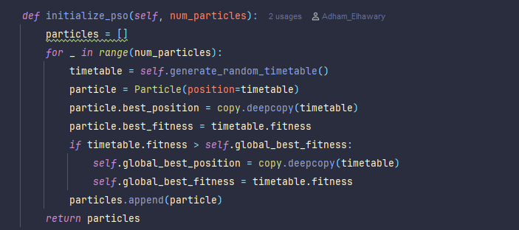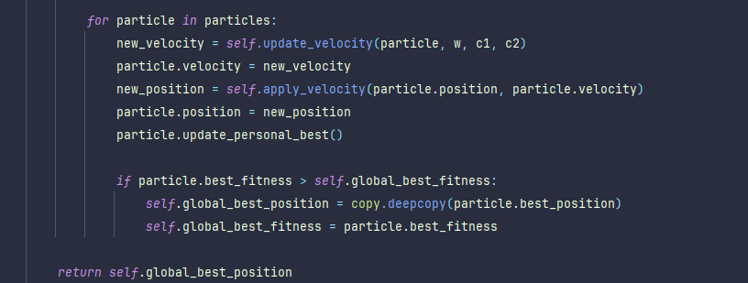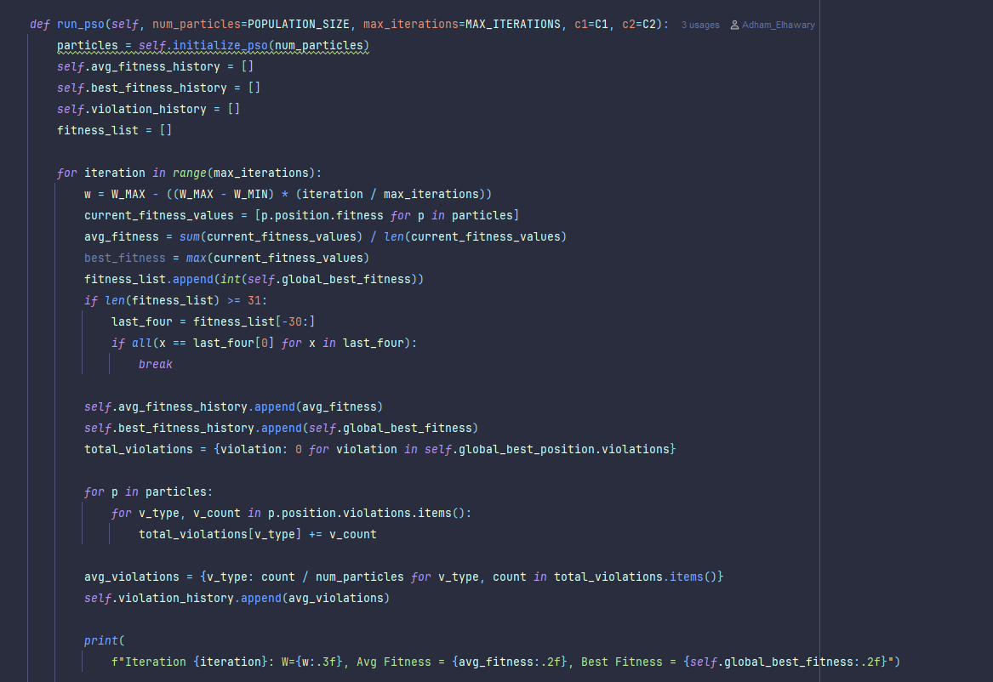


Genetic Algorithm (GA)
- Uses a population of Timetable instances.
- Each generation:
  - New population includes the best solution so far (elitism).
  - Parents are selected using tournament selection (with parameter TOURNAMENT_SIZE).
  - Children are created via crossover (controlled by CROSSOVER_RATE), swapping random assignments between parents.
  - Children may be mutated (based on MUTATION_RATE), changing room/time for a random assignment.
  - Fitness is evaluated; best solution is tracked.
- Next generation is built from these new children.
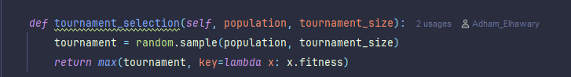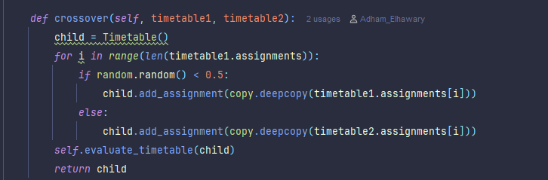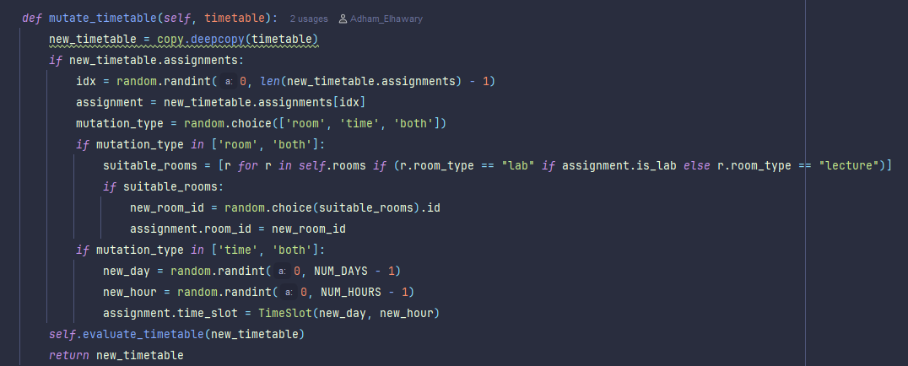
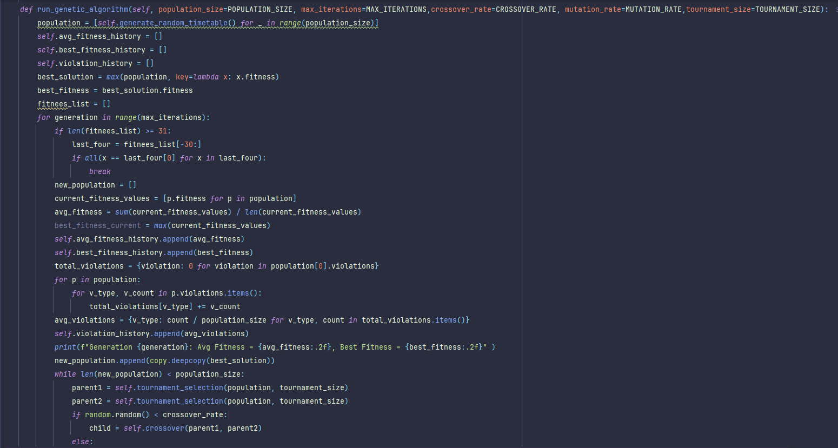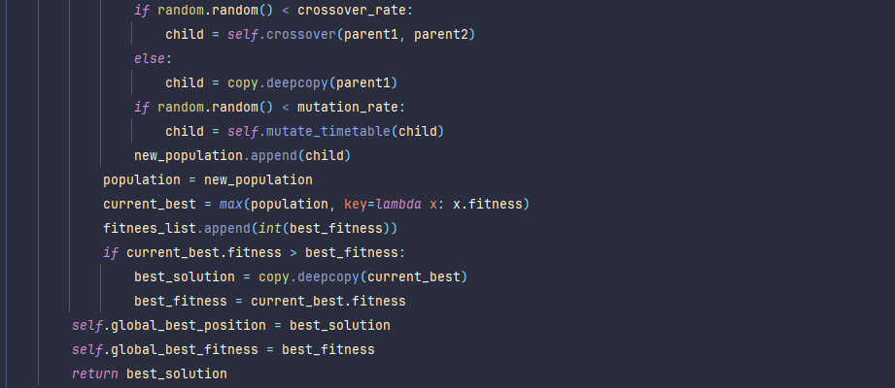

Hybrid Algorithm
- Uses Particle objects like PSO.
- In each iteration, each particle performs either:
  - PSO-style velocity update and position change, or
  - GA-style crossover/mutation (with another random particle).
- A probability (e.g., 0.5) decides which operator (PSO or GA) is applied.
- After updates, fitness is re-evaluated; personal/global bests are updated.
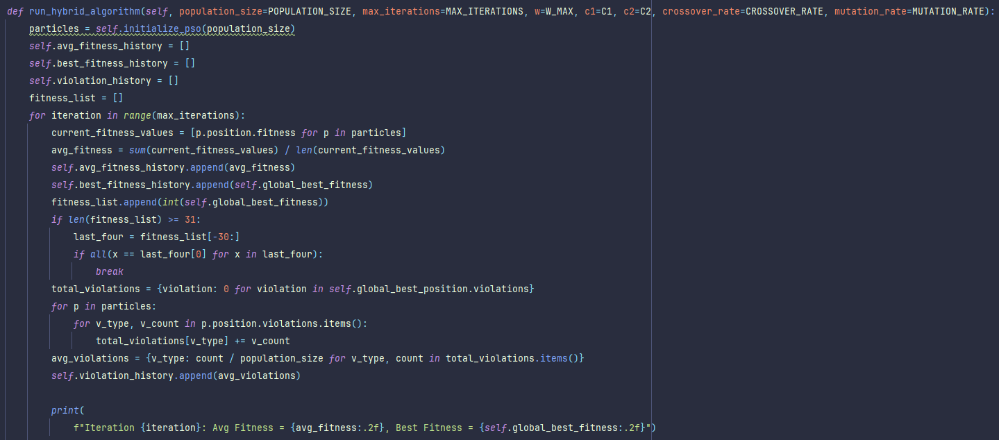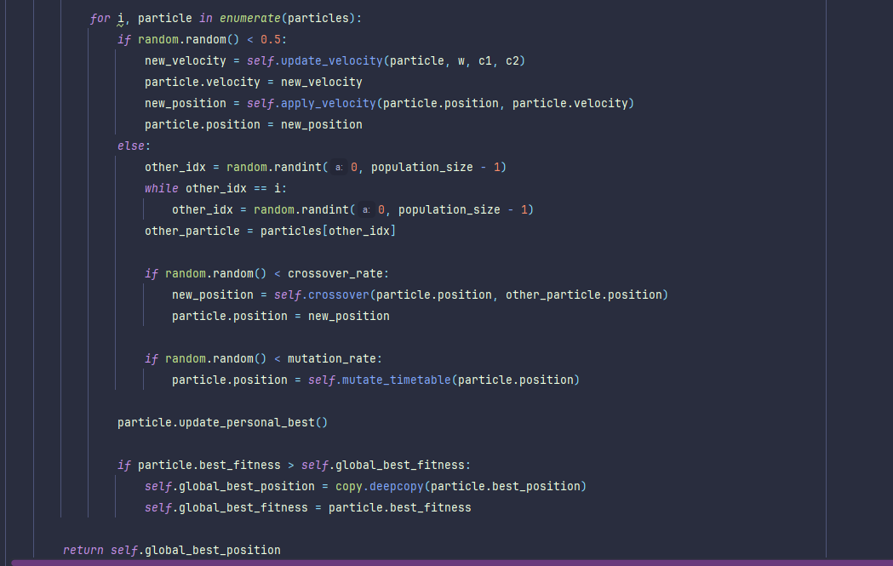

Additional Features
- Stopping Condition: All algorithms may stop early if the best fitness hasn't improved in the last 30 iterations/generations.
- Results Storage:
The UniversityTimetablingProblem instance stores:
  - Fitness history (average and best)
  - Violation history
  - Final solution and time taken
These results can be analyzed and visualized via the GUI using progress plots and comparison tables.
The complexity of the evaluate_timetable function and the specific penalty values significantly affect the outcome (fitness score) of generated timetables.
- Visual Experiment Results:
- Hybrid Algorithm
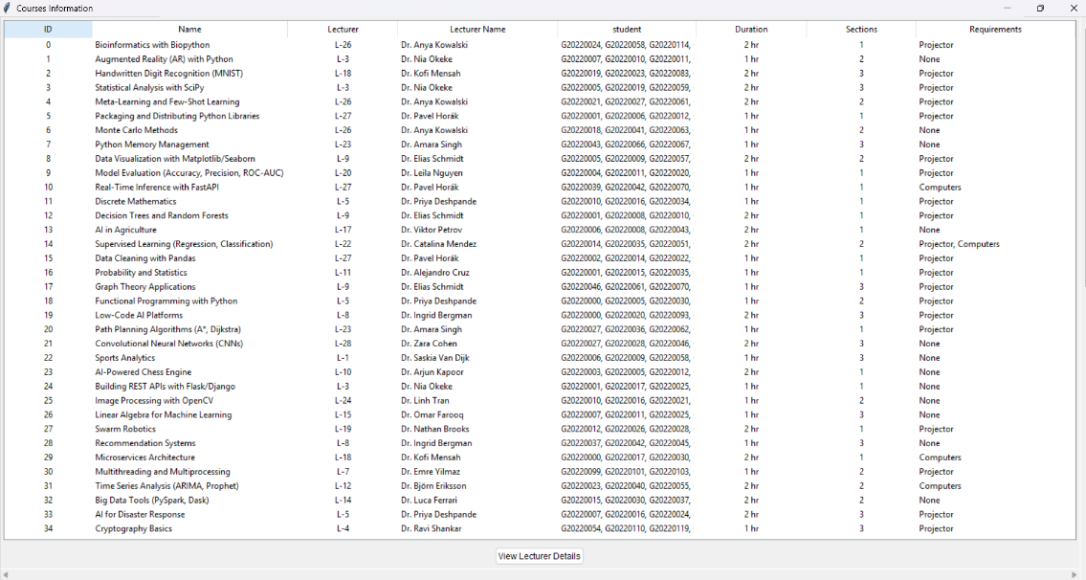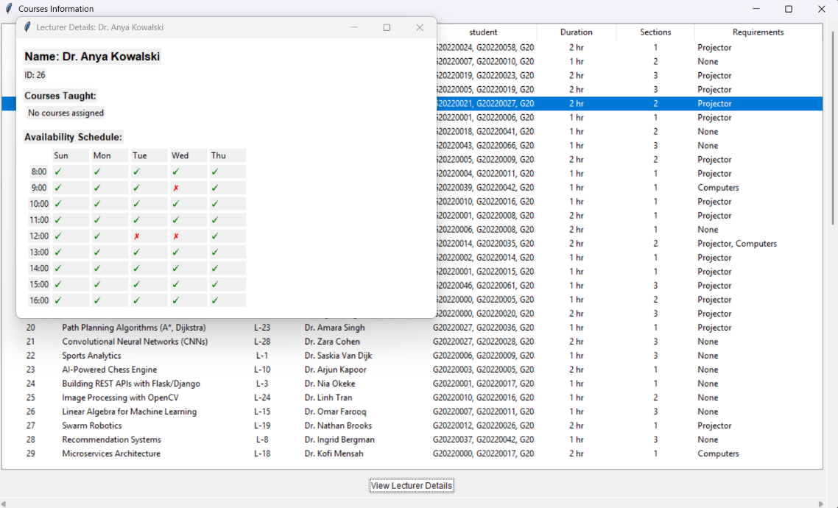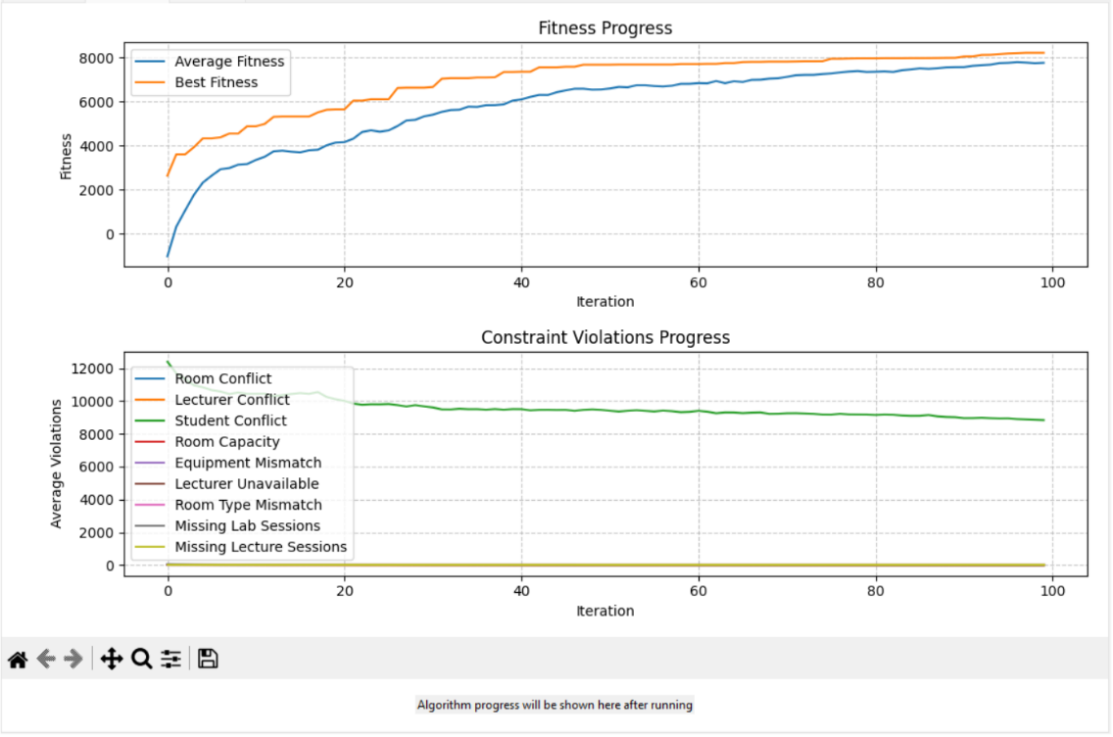
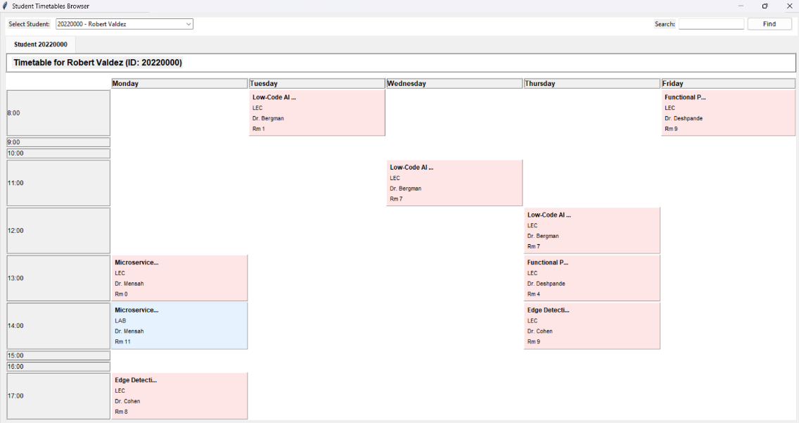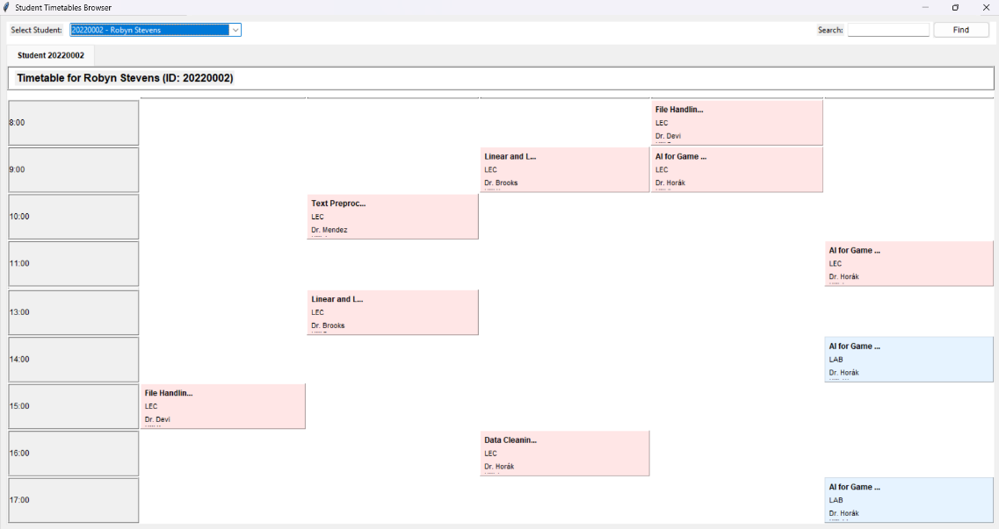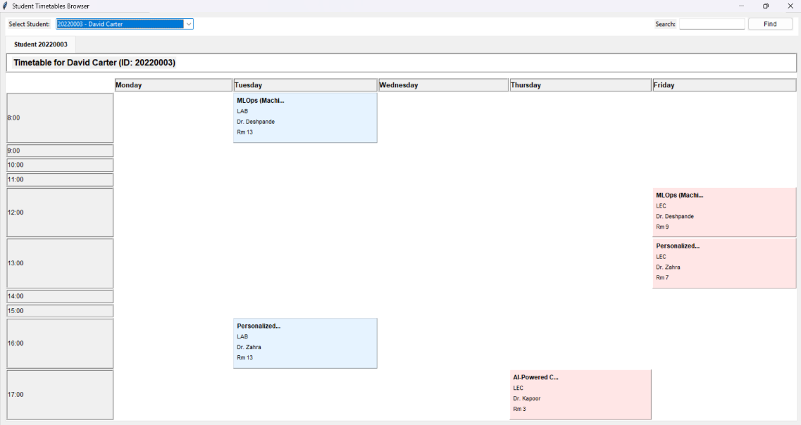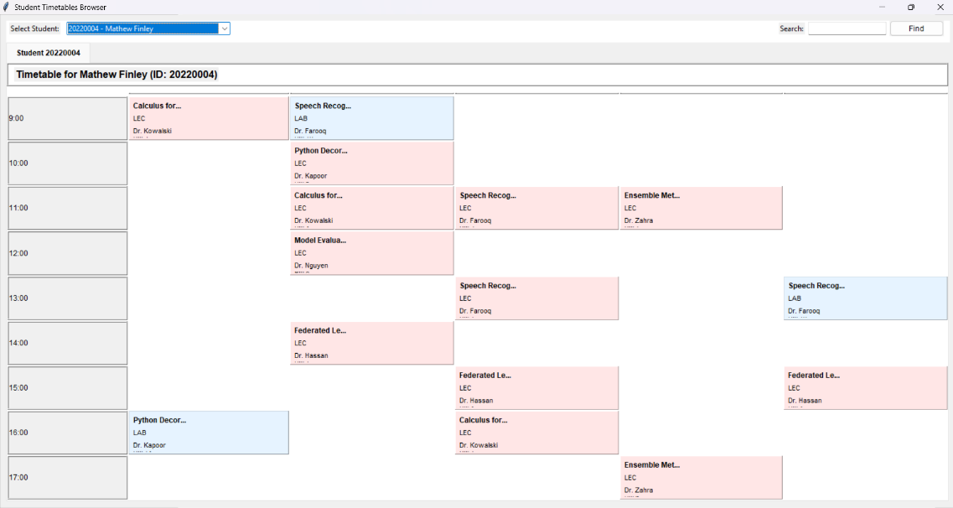

- PSO
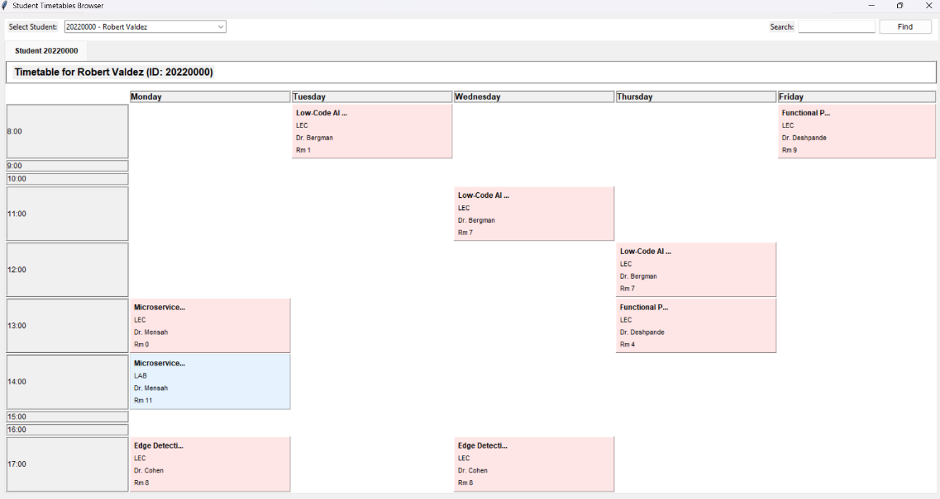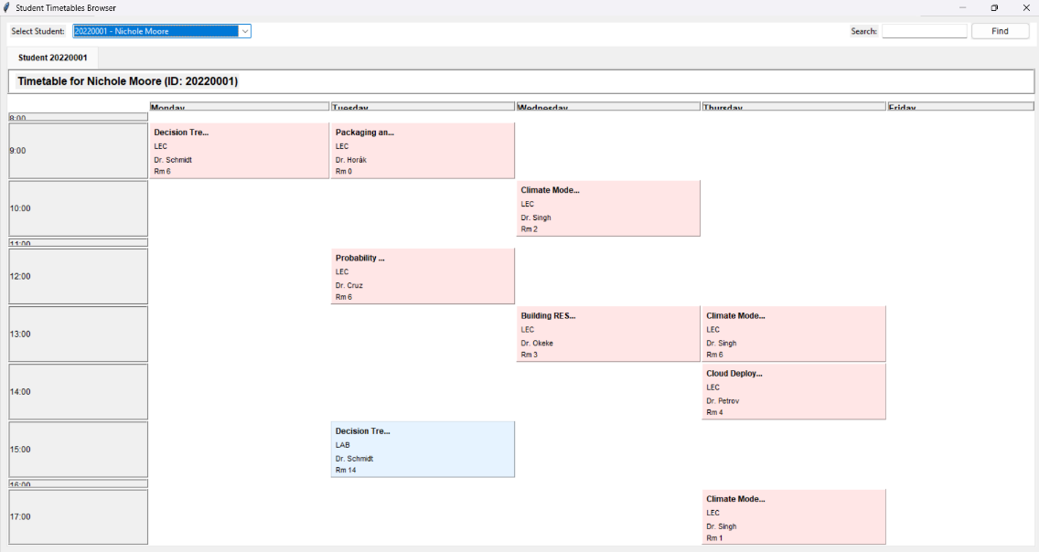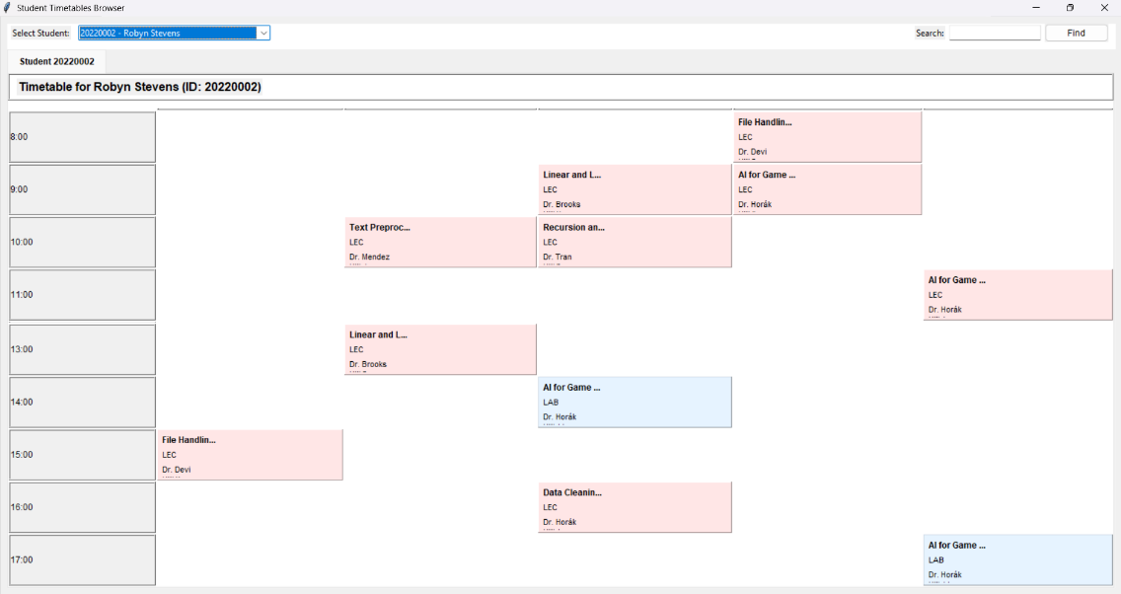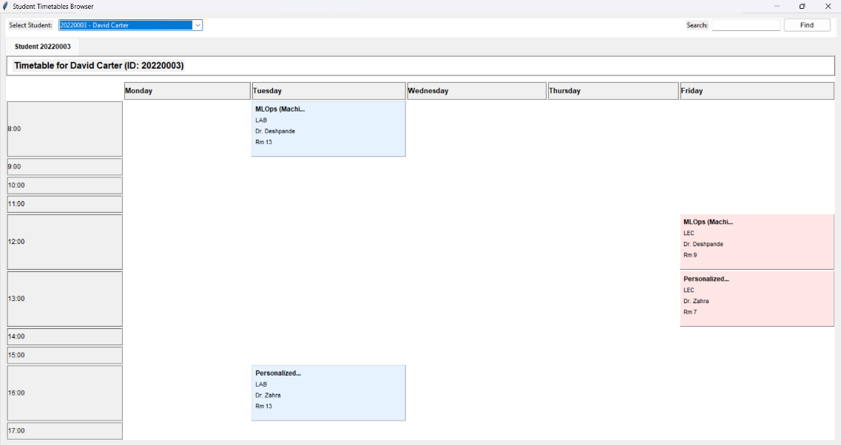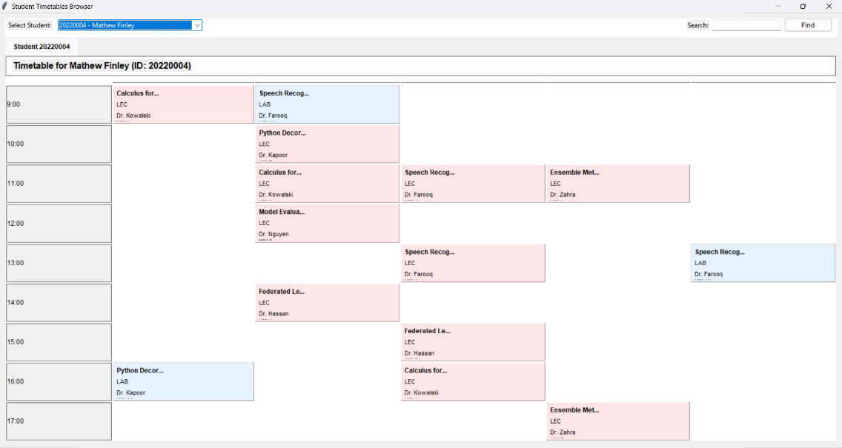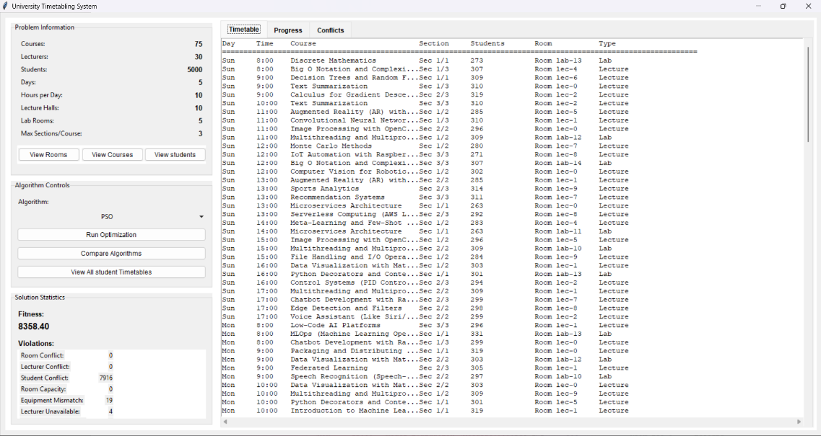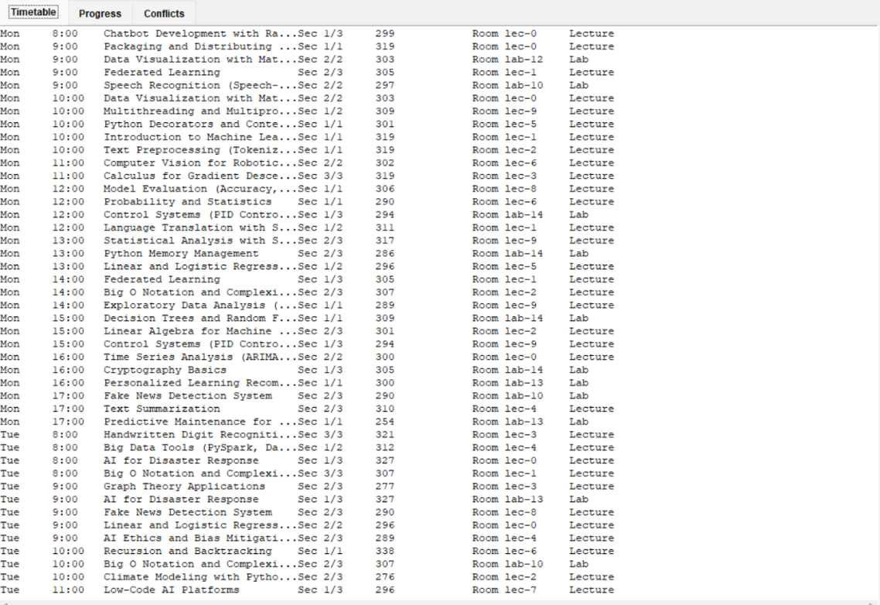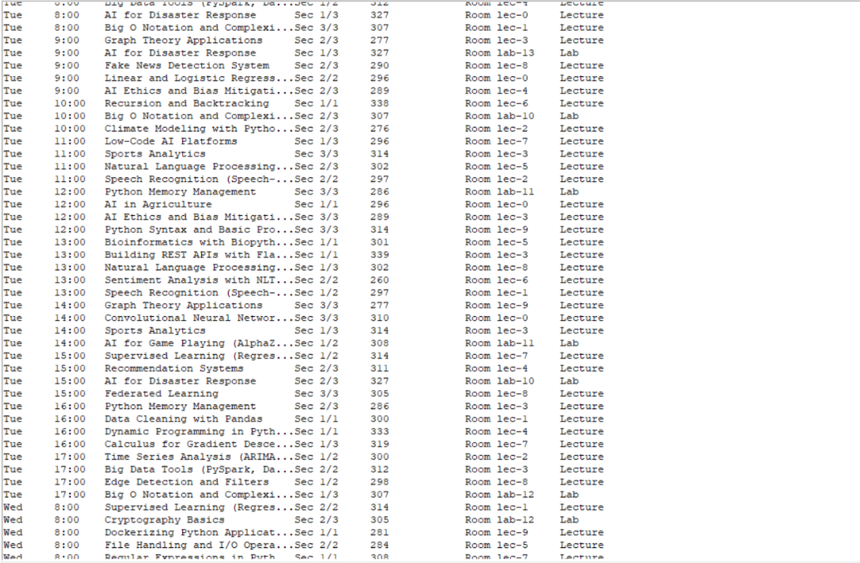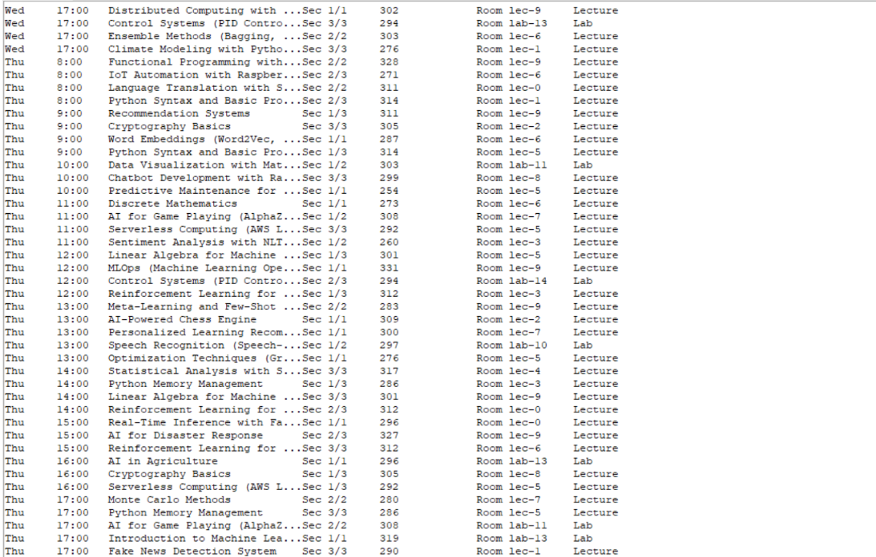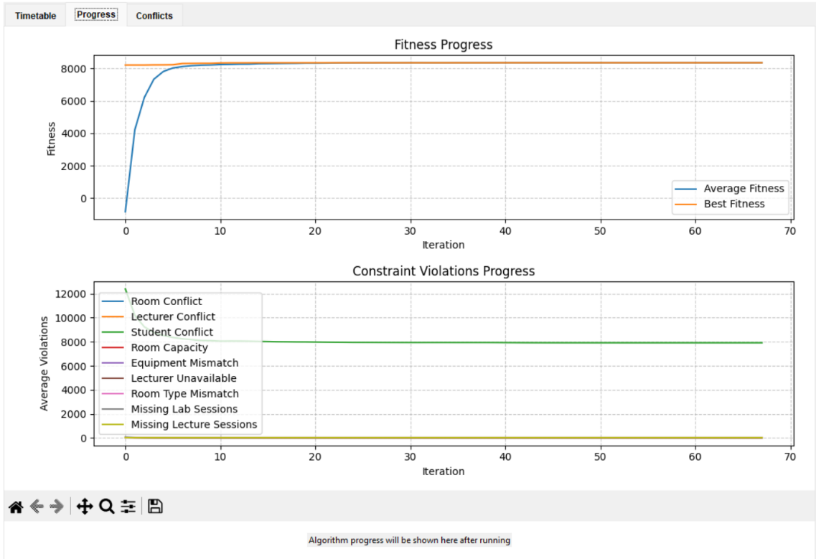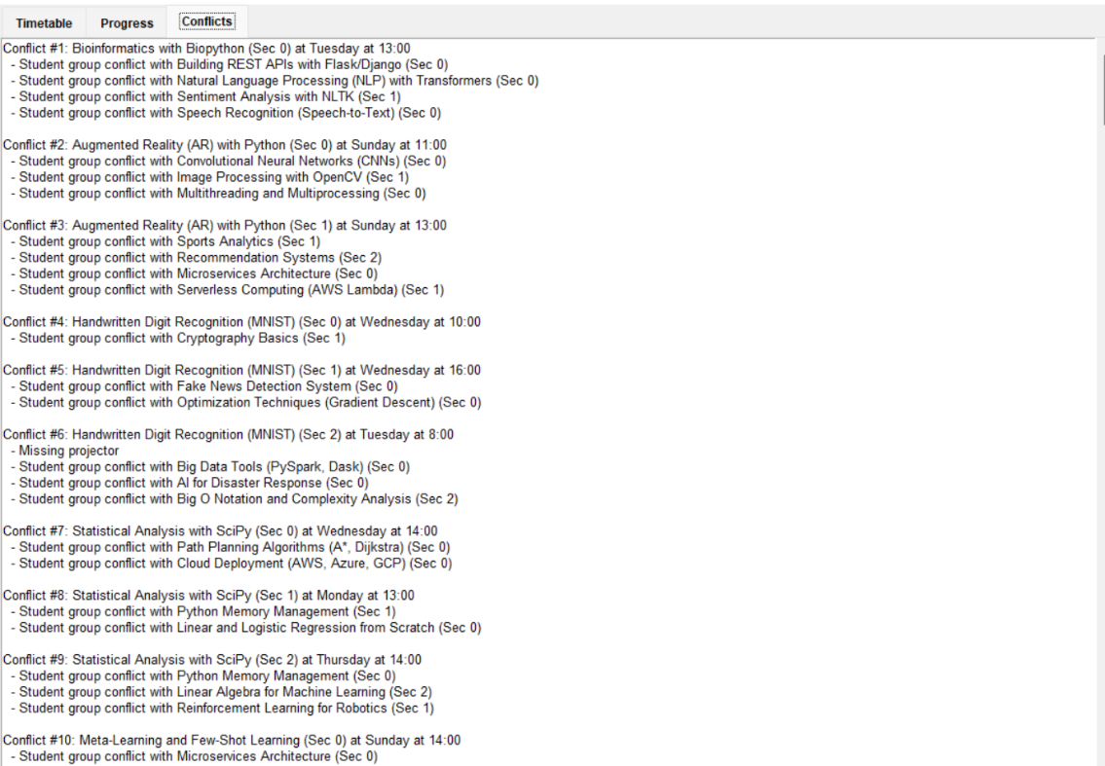

- Genetics
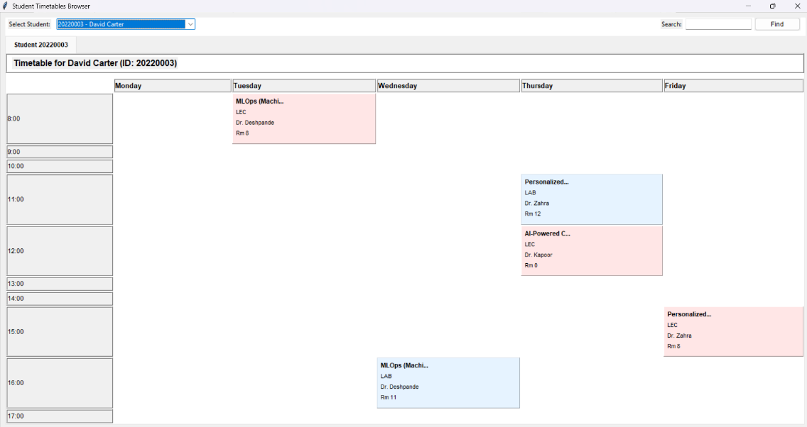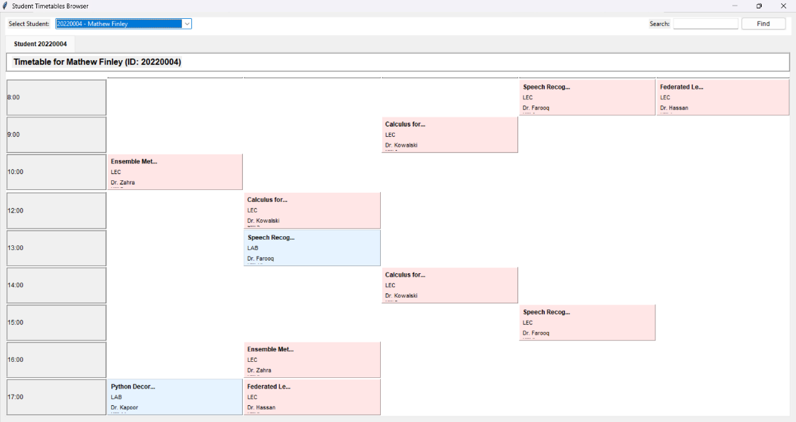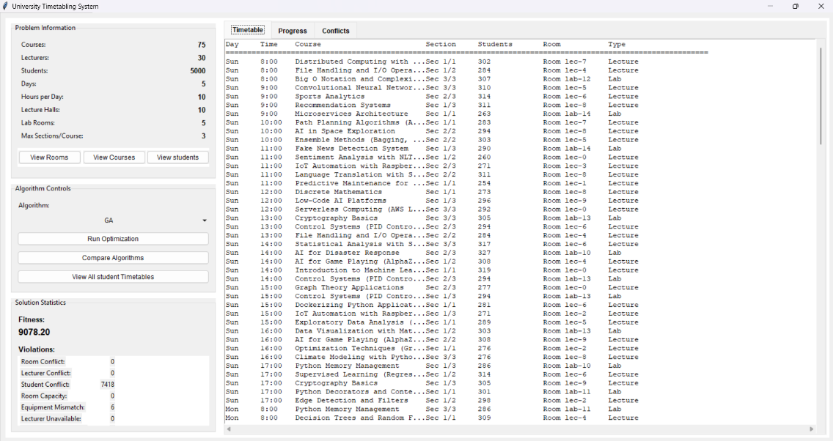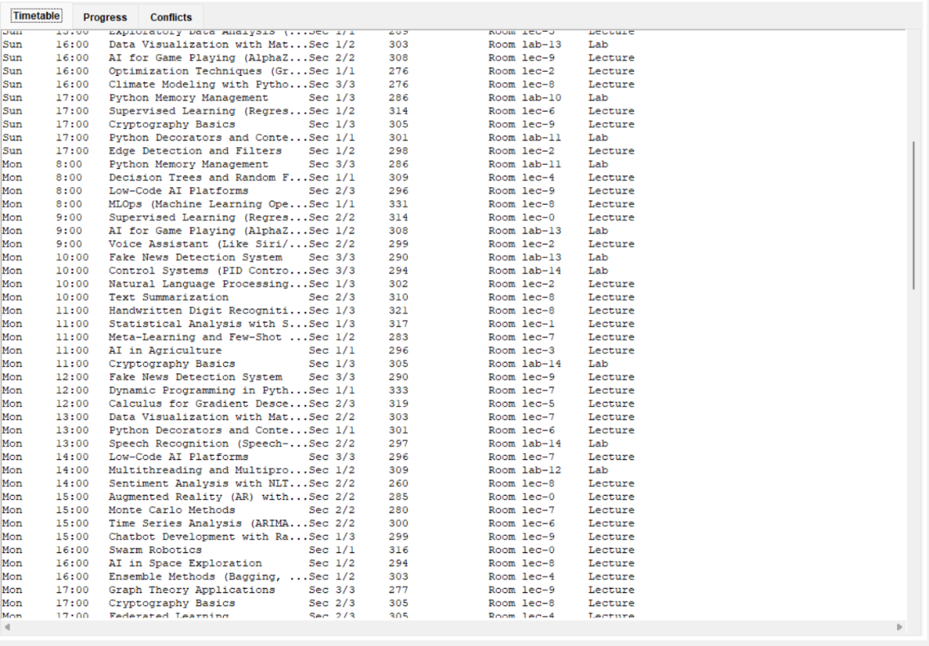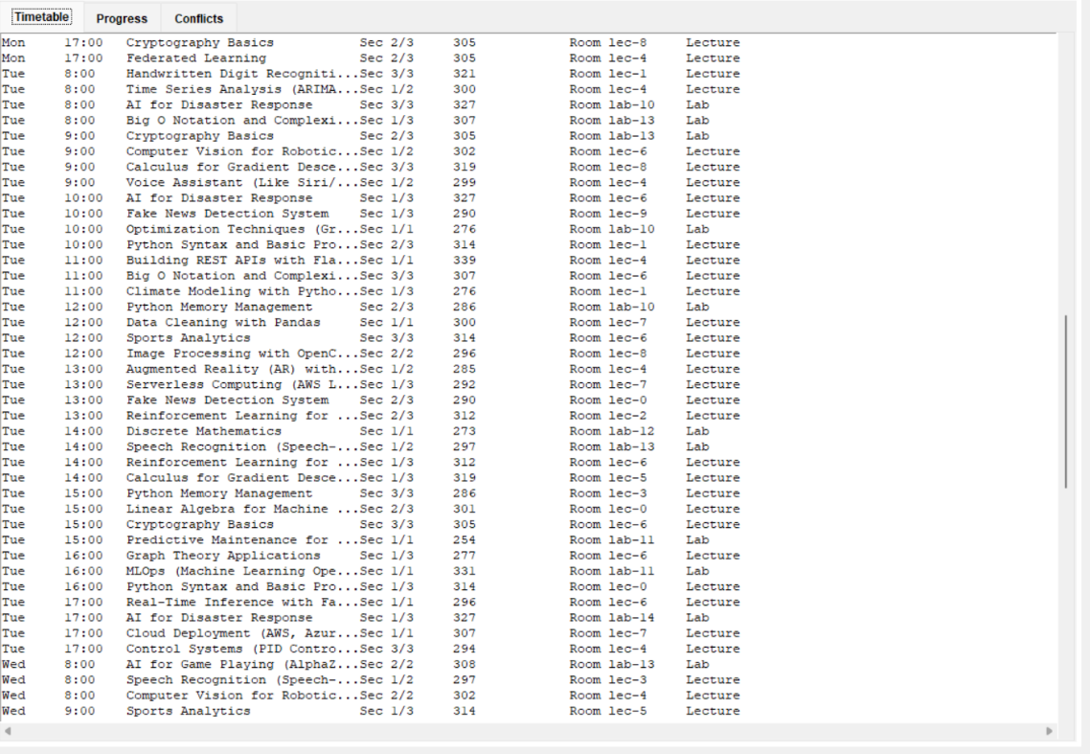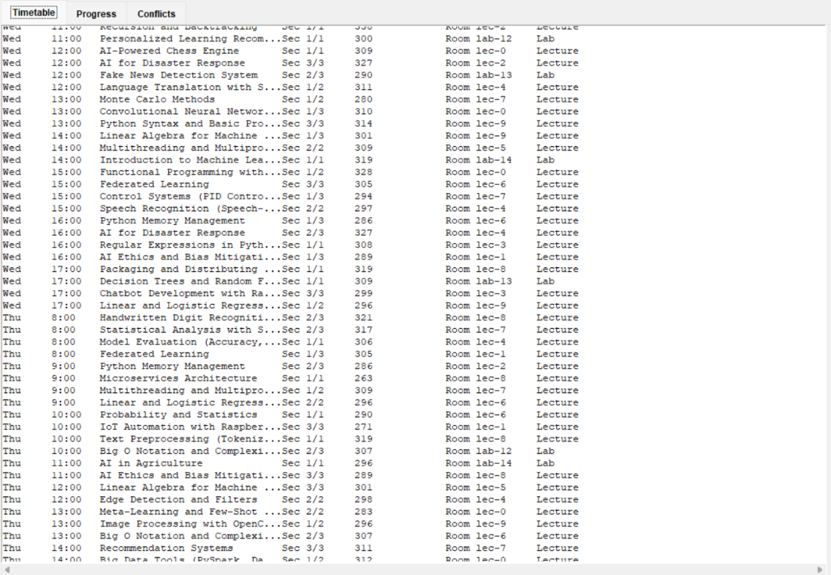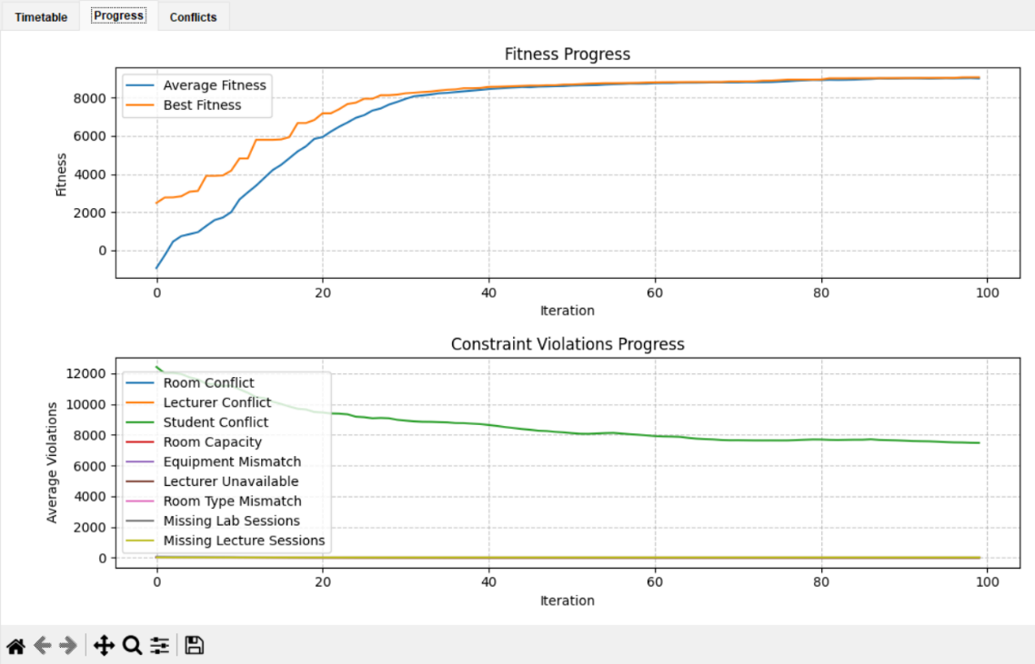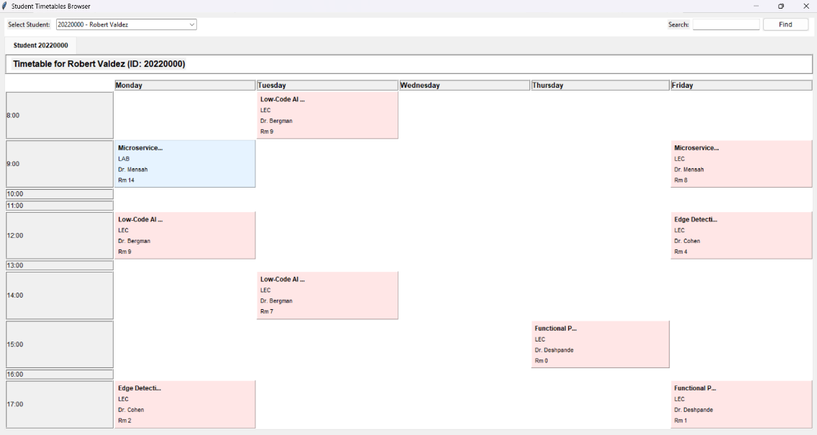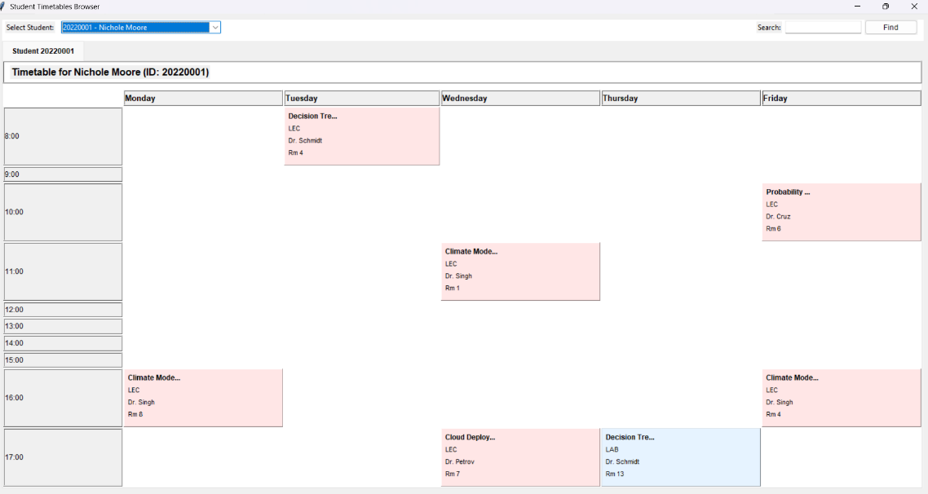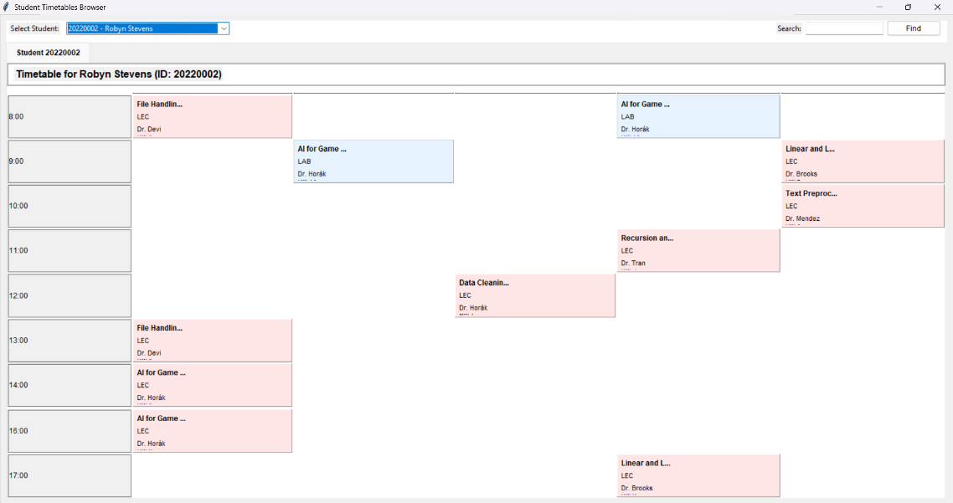

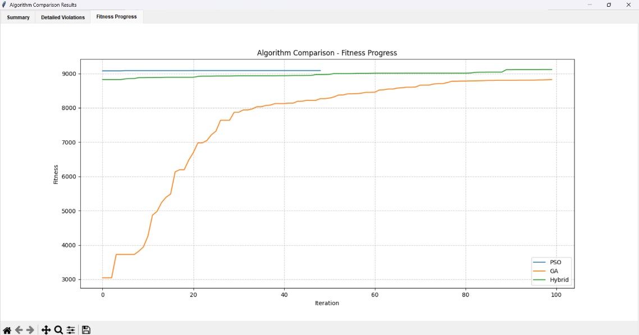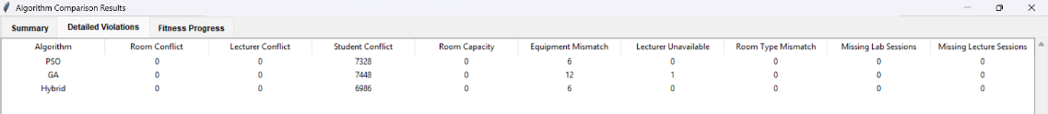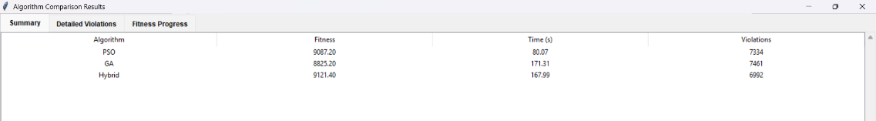

7. Development Platform
The application is developed in Python and utilizes a combination of standard and third-party libraries. It is designed as a desktop application with a graphical user interface built using Tkinter. Some features require additional tools like FFmpeg for full functionality.

Libraries and Tools Used
- pygame:
Used for audio playback during the loading screen.
- pandas:
Mentioned for reading CSV files (e.g., students.csv), although student data is primarily generated programmatically, bypassing the CSV input.
- PIL (Pillow):
Used for image processing, particularly converting OpenCV video frames into a format compatible with Tkinter.
- cv2 (OpenCV):
Used for video capture and processing in the loading screen animation.
- threading:
Ensures responsiveness by running optimization algorithms and video/audio playback concurrently with the GUI.
- numpy:
Used for numerical operations, especially representing lecturer availability in 2D arrays.
- matplotlib.pyplot and matplotlib.backends.backend_tkagg:
Used for visualizing the progress of fitness and constraint violations directly within the GUI.
- random:
Extensively used for generating synthetic data and introducing randomness in the metaheuristic algorithms.
- copy:
Critical for making deep copies of timetable objects and particles during algorithm operations.
- tkinter and tkinter.ttk:
Core libraries for building the desktop GUI interface.
- time:
Used to track and display algorithm execution time.
- os and tempfile:
Used to manage temporary files, particularly for handling audio extracted from video clips.
- subprocess:
Used to invoke external tools like FFmpeg for extracting audio from video files for the loading screen.

Additional Notes
The application may require FFmpeg to be installed and accessible in the system's environment for proper audio playback functionality during the loading screen. All other libraries are Python-native or installable via pip.

